 | 7.1.42 Editors - 3D Viewport - Header - Hair Curve - Edit mode - Curves menu
Table of content
Edit mode - Curves menu 1
Transform 2
To Sphere 2
Usage 2
Last Operator To Sphere 2
Factor 2
Proportional editing 2
Proportional Falloff 2
Proportional Size 2
Connected 2
Projected(2D) 2
Shear 3
Last Operator Shear 3
Offset 3
Axis 3
Axis Ortho 3
Orientation 3
Proportional editing 3
Proportional Falloff 3
Proportional Size 3
Connected 3
Projected(2D) 3
Bend 3
Push/Pull 4
Last Operator Push/Pull 4
Distance 4
Mirror Editing 4
Proportional editing 4
Proportional Falloff 4
Proportional Size 4
Connected 4
Projected(2D) 4
Radius 4
Set Attribute 4
Delete 5

Edit mode - Curves menu

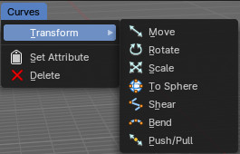
Transform

To Sphere
Shapes a selection of objects into the shape of a sphere. The calculation happens with the object origins.
In Object mode this tools requires to have more than one object selected.

Usage

Select the objects, activate the tool, then drag the mouse in the 3D viewport. In the header you will read the current factor then. Which tells you how close you are towards the sphere shape.
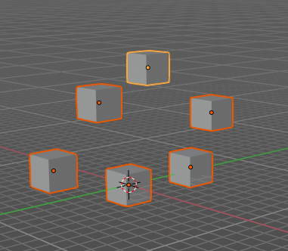
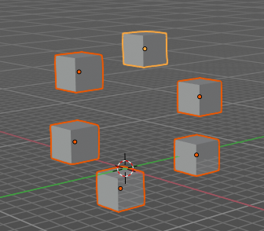

Last Operator To Sphere

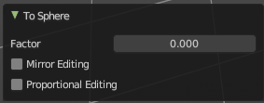
Factor
The factor to transform the selection into a shape form.

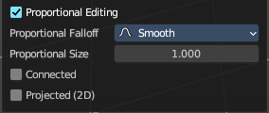
Proportional editing
Enables proportional editing. Activating proportional editing reveals further settings.

Proportional Falloff
Adjust the falloff methods.

Proportional Size
See and adjust the falloff radius.

Connected
The proportional falloff gets calculated for connected parts only.

Projected(2D)
The proportional falloff gets calculated in the screen space. Depth doesn't play a role. When it's in the radius, then it gets calculated.

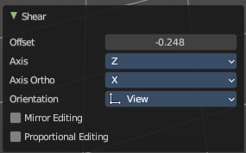
Shear
Shear shears the selection.
In Object mode this tools requires to have more than one object selected.

Last Operator Shear

Offset
Adjust an offset.

Axis
Defines one axis of the imaginary shear axis plane.


Axis Ortho
Defines the other axis of the imaginary shear axis plane.

Orientation
Choose the orientation for the shear action.

Proportional editing
Enables proportional editing. Activating proportional editing reveals further settings.

Proportional Falloff
Adjust the falloff methods.

Proportional Size
See and adjust the falloff radius.

Connected
The proportional falloff gets calculated for connected parts only.

Projected(2D)
The proportional falloff gets calculated in the screen space. Depth doesn't play a role. When it's in the radius, then it gets calculated.

Bend
Bends the selection.
In Object mode this tools requires to have more than one object selected.

Push/Pull
It pushes or pulls the object positions relative to the center of the selection.
In Object mode this tool requires to have more than one object selected.

Last Operator Push/Pull

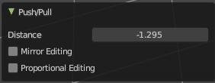
Distance
Adjust the strength of influence of the tool.

Mirror Editing
Enables mirror editing.

Proportional editing
Enables proportional editing. Activating proportional editing reveals further settings.

Proportional Falloff
Adjust the falloff methods.

Proportional Size
See and adjust the falloff radius.

Connected
The proportional falloff gets calculated for connected parts only.

Projected(2D)
The proportional falloff gets calculated in the screen space. Depth doesn't play a role. When it's in the radius, then it gets calculated.

Radius
Scales the selected curves point along its normals.
A positive value pushes the vertices width outwards. A negative value pushes the vertices width inwards.
Notes: Transform orientation and Pivot point gets ignored. To see the result, make sure you have geometry radius applied, without this will be set into the Radius attribute.

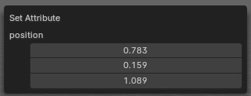
Set Attribute
Set the position attribute of the selected elements. The values can be adjusted in the popup.

Delete
Deletes the selected hair curves.

